**Task 1: Installing NASM**

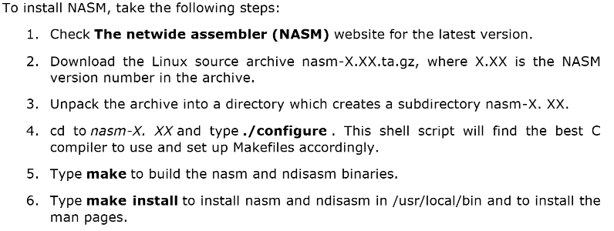

You may choose other methods. Whatever works…

**Task 2: Verify Installation**

1. Copy the code given on the next page to a file titled “hello.asm”
2. Run the following command and make sure the program runs perfectly. It should print “a=5, b=2 c=7”. You may change the values of a and b in the source code.

nasm -f elf64 hello.asm && gcc -o hello hello.o && ./hello

1. End of lab for today.

extern printf

SECTION .data

a: dq 5

b: dq 2

c: dq 0

fmt: db "a=%ld, b=%ld c=%ld", 10, 0

SECTION .text

global main

main:

push rbp

mov rax,[a]

mov rbx,[b]

add rax,rbx

mov [c],rax

mov rdi,fmt

mov rsi,[a]

mov rdx,[b]

mov rcx,[c]

mov rax,0

call printf

pop rbp

mov rax,0

ret